The Oxford Edition of the Writings of Alexander Pope,
in collaboration with
The Centre for Literary Editing and the Materiality of the Text,
University of Birmingham
Alexander Pope:
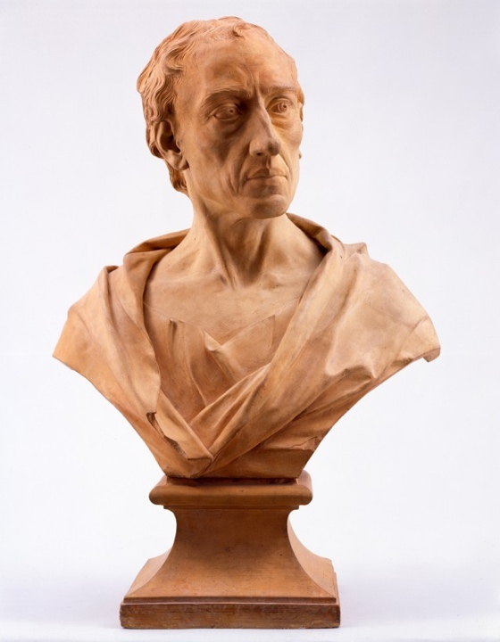
Text, Book, Work

A symposium
Wednesday 27 June 2018
Lecture Room 2, Arts Building,
Edgbaston Campus, University of Birmingham

Booking now open! For further details, see our blog page at https://blog.bham.ac.uk/apope18/2018/03/29/registration/

Image courtesy of the Barber Institute of Fine Arts, University of Birmingham

