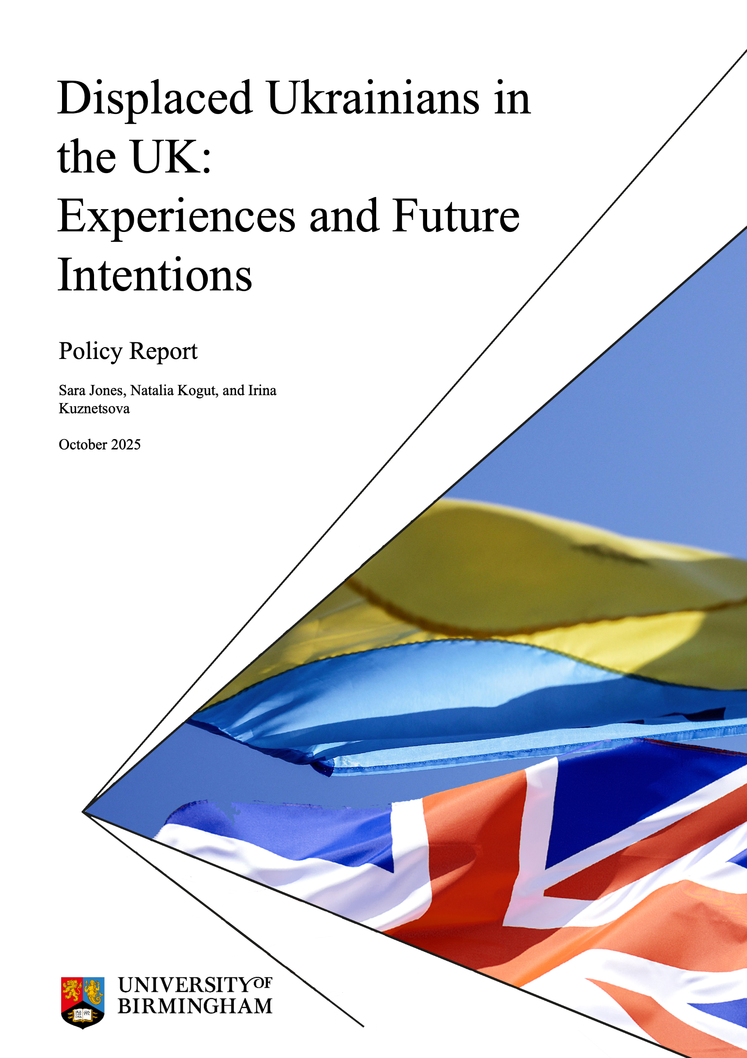

Acknowledgements
This research and its dissemination were funded by the University of Birmingham Institutional Impact Fund and QR Policy Support Fund.
We are grateful to our project partners, especially Simone Schehtman, Yuliia Ismail, Steve Osbiston, Anna Zagrebelna, and Stan Benes for the fruitful discussions, feedback on the report, and help in recruitment of participants for the survey. Thanks are also given to Opora for their help in disseminating the survey. We are very grateful to all the respondents for giving their time to share their experiences and perspectives.
The Executive Summary was drafted with assistance from M365 Copilot and edited and verified for accuracy by the authors.
Cover Image: Oxana Bischin

Contents
Recommendations 4
Executive Summary 4
Introduction 5
Impact of War 7
Migration Journey and Visa Status 7
Access to Employment 10
Access to Housing 13
Access to Education 14
Family Relationships 15
Health and Well-Being 16
Future Plans 17
Conclusion 20
Notes 22

Recommendations
- Ensure that the 24-month extension to the Ukraine Permission Extension (UPE) is applied through a simple and accessible system with a minimum of bureaucracy – ideally automatically for those already holding UPE visas.
- Include the time spent in the UK on the Ukraine Scheme visas (including Ukraine Sponsorship Scheme, Ukraine Family Scheme, Ukraine Extension Scheme, and Ukraine Permission Extension) in the qualifying period for the 10-year Long Route to permanent residency.
- Create a designated 5-year pathway to residency for displaced Ukrainians who have been continuously resident in the UK under the Ukraine Schemes.
- Ensure that displaced Ukrainians – especially displaced children – have continued access to Ukrainian culture and language, e.g., through the introduction of a Ukrainian GCSE.
- Work with employers, job centres and relevant NGOs to ensure that the qualifications, skills and experience of displaced Ukrainians are fully recognised (including formal recognition of professional qualifications).
- Improve access to dedicated mental health support for displaced Ukrainians, ideally in Ukrainian and making use of the skills of Ukrainian medical professionals.

Executive Summary
Since Russia’s full-scale invasion of Ukraine in February 2022, over 218,000 displaced Ukrainians have arrived in the UK under the Ukraine visa schemes. These initially offered three-year stays, later supplemented by the Ukraine Permission Extension (UPE), which now grants an additional 18 months of temporary residence, with a further extension of 2 years announced. However, there remains no pathway to permanent settlement, and time spent under these schemes does not count toward the UK’s 10-year Long Route to permanent residency. A nationwide survey of nearly 3,000 Ukrainians reveals the deep emotional and practical toll of this uncertainty. Respondents report widespread challenges in employment, housing, education, and mental health, with many struggling to secure jobs or leases due to their temporary status. Although most found the UPE application process manageable, technical issues and confusion – especially around dependent children – have caused delays and distress.
Despite high levels of economic activity and improving English proficiency, many Ukrainians are working below their skill level, earning wages far below the threshold for Skilled Worker visas. Visa precarity has led to job rejections, contract terminations, and missed professional opportunities. Housing access is similarly strained, with many facing lease refusals or eviction risks due to visa expiry. Young people comprise a large share of the arrivals, with 28% of displaced Ukrainians in the UK being under 18. Education is another area of concern: children have integrated into UK schools, and parents fear the trauma of uprooting them again. Adults are hesitant or unable to pursue higher education or apprenticeships without long-term immigration status and security, or to commit to more senior roles where long-term training is needed. Mental health issues are prevalent, with significant numbers diagnosed with anxiety, depression, or PTSD, and many unable to access therapy in their preferred language.
The majority of respondents express a strong desire to remain in the UK – even if Ukraine becomes safe. Only 5% say they would return, citing fears of renewed Russian aggression, destroyed infrastructure, economic instability, and lack of personal safety. Many have no homes to return to, and some face risks due to conscription, ethnicity/language, or sexual orientation. For many, the UK has become more than a refuge – it is home. Yet the absence of a settlement pathway leaves them in a state of limbo, unable to plan for their futures or their children’s.
To support displaced Ukrainians in building stable lives in the UK, the government should simplify and automate the visa extension process, count time spent under Ukraine Schemes toward long-term residency, and establish a clear designated 5-year pathway to settlement. Additional measures should include improving access to Ukrainian language and culture, formally recognising Ukrainian qualifications, and expanding mental health support – ideally delivered in Ukrainian by qualified professionals.

Introduction
Since the full-scale Russian invasion of Ukraine in February 2022, the UK has issued 267,200 visas under the Ukraine Schemes – 218,600 Ukraine Scheme visa holders have arrived in the UK.¹ The three original Ukraine Schemes (Ukraine Family Scheme, Ukraine Sponsorship Scheme, Ukraine Extension Scheme) initially offered visas for 3 years.² In February 2025, the UK government opened the Ukraine Permission Extension, providing a further 18 months for those with continuous residency in the UK on the Ukraine Schemes when their initial visa came to an end. However, there is currently no designated pathway to settlement for displaced Ukrainians in the UK and – since November 2024 – the time spent in the UK on the Ukraine Schemes does not count towards the qualifying period for the 10-year Long Route to permanent residency.
Our first report, “Impact of Changes to the Ukraine Visa Schemes on Ukrainians in the UK” (March 2025) demonstrated the material and emotional impact of the precarity caused by the short-term nature of the Ukraine Scheme visas. The results of our first survey showed that Ukrainians were struggling to find jobs and rental properties, were not having employment or tenancy agreements renewed, and had difficulties accessing Higher Education. Ukrainians reported high levels of anxiety and poor mental health.³ Our research on young Ukrainians in the UK demonstrated persistent issues relating to access to employment, housing, and healthcare, and provided strong evidence that most young Ukrainians want to stay in the UK and contribute to their local economies and communities.⁴
The research underpinned significant policy engagement across the political spectrum, including the Early Day Motion 1000 Ensuring Stability for Ukrainian Refugees in the UK (the most-signed EDM in that parliament with 121 signatures)⁵ and the Adjournment Debate on 21 July 2025,⁶ at which the then Minister for Migration and Citizenship (Seema Malhotra) announced the extension of the Ukraine Permission Extension. On 1 September 2025, this was confirmed by the then Secretary of State for the Home Department (Yvette Cooper) to be by a further 24 months.⁷
The addition of two years offers some stability to displaced Ukrainians in the UK; however, it falls short of long-term security for those who have made the UK their home and may not want or be able to return to Ukraine at the end of the war.
This report presents the results of a survey of 2984 Ukrainians who have arrived in the UK since March 2022. The survey asked a range of questions relating to respondents’ migration journey, visa status, experiences accessing jobs, housing, benefits and loans, future plans, health and well-being, and the impact of the war on their lives. The survey was administered online in Ukrainian language, and disseminated via social media (principally on groups relating to Ukrainians in the UK) in September 2025.⁸ Only adults over 18 years old could participate in the study. Of our respondents, 76% were women and 24% men across various ages, ethnicities, and territories of origin. The majority of the participants (75%) reside in England, 5% in Wales, 16% in Scotland, and 3% in Northern Ireland. This largely reflects the demographics of the broader population of displaced Ukrainians in the UK.⁹

Impact of War
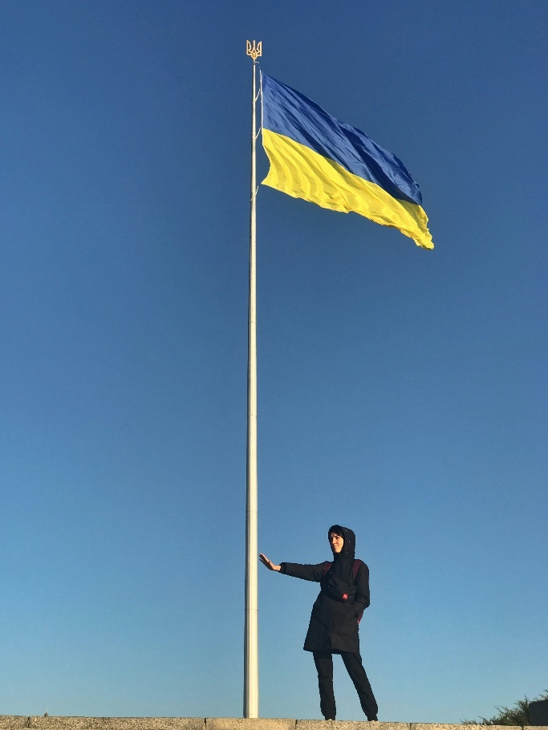The full-scale Russian invasion of Ukraine in February 2022 has impacted our respondents in a myriad of ways. Almost a third (28%) of those answering our survey have lost close family members due to the war.
Photo by Artur Voznenko on Unsplash
Leaving one’s home – often with children in tow – and starting afresh in a new country is always a challenging experience. Amongst our respondents, 8% also had prior experience of (internal) displacement – that is, they had resettled from occupied territories after 2014 and before 2022. As previous studies demonstrate, many residents and former residents of Donetsk and Luhansk oblasts experienced loss of home, marginalisation and issues with access to some civil rights before 2022.¹⁰
My eldest son died in the war, and I am very worried about the life of my youngest son who is now with me in the UK
14.5% of respondents are from regions currently (at October 2025) occupied entirely or partially by Russian forces. Many Ukrainians have also lost their homes: 54% of our respondents own property in Ukraine: of those, 23% state it is damaged, 5% completely destroyed, and 10% captured by the occupying forces. These numbers do vary by region, with 39% of respondents from the currently occupied territories stating that their property is damaged, destroyed, or occupied; this figure is 10.5% for respondents from the other regions of Ukraine.

Migration Journey and Visa Status
As Figure 1 shows, the vast majority (97.9%) of our respondents hold a Ukraine Scheme visa (including UPE). 43.4% have status under one of the original Ukraine Schemes, and 54.5% hold a UPE visa.
Only 6 respondents hold a humanitarian protection visa or refugee status (0.2%), and only nine respondents state that they are asylum seekers (0.3%). 1% of respondents hold a Skilled Worker or Global Talent visa

Figure 1: Visa type held by displaced Ukrainians
Of those still on the original Ukraine Scheme visas, 45% have applied for UPE and are awaiting the outcome, 53% say it is too early for them to apply, only 1% will apply for a different kind of visa, and 1% plan to leave the UK.
The UPE application system appears to be working fairly smoothly overall: 34% of those who applied to UPE received their visa within a week of applying, 26% in 1-2 weeks, and 18% in 3-4 weeks, only 4% say it took longer than 8 weeks. 75% state that the UPE application process was clear or very clear. Only 6% got help from a lawyer or consultant in completing their application (of those, only 20% paid for that support).
Nonetheless, a significant proportion of respondents (26%) did experience difficulties applying for UPE, with the main problems relating to the system not scanning biometric data (39%), the website crashing (23%), and the application not appearing on the applicant’s e-visa (18%). 5% note that their entitlement to 3C leave (indicating their continued rights as they wait for their visa application to be processed) did not show on their e-visas.
A substantial number of respondents provided further details on the problems they encountered applying for UPE. These free-text comments were coded by topic to identify key themes in the data.¹¹

Figure 2: Most frequently mentioned issues with UPE application (% free text responses)
As Figure 2 shows, the most common issues encountered whilst applying for UPE are unclear questions, technical problems scanning the passport, difficulty making and attending biometrics appointments or with existing biometric data not being reflected in the UKVI account, providing data about previous addresses, E-visas showing incorrect status or no 3C leave, difficulties generating a family linking code and/or using it where there is significant variability in the visa end date of different family members, a lack of information on what documents should be attached and when, and a lack of clarity about when parental details need to be provided (and unavailability of that information for some applicants).
There was a system error with dates – because of this, my adult child lost their job, and housing was at risk. We fought for 3 weeks, and finally received the visa.
Approximately 17% of those for whom it is relevant had problems applying for UPE for their children; for example, issues relating to birth certificates, expired passports (Ukrainian children’s passports are only valid for 4 years), the need for both parents to provide consent, or a lack of awareness that each child needs a separate UKVI account.
There was no clear information about needing permission from the other parent. In my case, it was important to know this in advance and prepare accordingly. No one really mentioned it, and when I faced it close to the deadline, I panicked.

Access to Employment
More than three-quarters (76%) of our respondents are economically active, with 56% working more than 30 hours per week (employed or self-employed). A further 7% are students, 7% are unemployed and actively looking for work, 3% are on temporary or long-term sick leave, 3% are on parental or carers leave, and 1% are retired.¹² 67% send remittances of some kind back to Ukraine several times per year (34% do so monthly).
A significant proportion of our respondents (36%) state they had no problems finding work in the UK. For the remaining 64% who did experience challenges, these relate to: English language skills (30%), finding a job to match skills (21%), qualifications not being recognised (19%), finding a job close to home (19%), finding a job that pays enough (14%), and childcare (13%). It is worth noting that 75% of respondents rate their English proficiency as at least “intermediate” (44%), with 25% stating they are “advanced” and 6% “proficient”. Only 25% consider themselves to be “beginner” or “pre-entry”. While level of English might continue to be a barrier to employment, it is increasingly one that is being overcome.
Respondents were asked to provide their average weekly wage (see Figure 3). The mean of the responses given is £524.75, and the median is £462. The standard threshold for a Skilled Worker Visa is currently approximately £802/week (based on 52 weeks/year). Only 127 of the 1646 respondents who answered this question (8%) would currently meet that particular requirement to switch to SWV (noting that salary level is not the only eligibility criterion).

Figure 3: Average weekly wage (% of responses in each band)
A key issue in this context is “downskilling”, that is, working below one’s level of experience and qualifications.¹³ Of those working, two-thirds of our respondents (67%) state that their job is below their skill level. To give just one example of the shift seen between the two countries: only 2 of 848 respondents (0.2%) state they worked in cleaning jobs in Ukraine – this figure is 86 of 748 respondents (11.5%) in the UK. These individuals had occupied a wide variety of professions in Ukraine, from finance and business, public sector (including emergency services and education), to specialised fields such as bioscience and psychology.
I feel that employers are very cautious about the Ukraine Scheme visa. They don’t understand it – it’s not common in the market. They prefer candidates with unrestricted visas. Some employers even state on their websites that applicants must have a valid UK passport or Indefinite Leave to Remain, which requires at least 5 years of residence in the UK.
The data indicate that skills held by displaced Ukrainians in key sectors are being underused. 194 respondents indicated they had worked in the health care sector in Ukraine: only 23% of them are currently employed in health care in the UK, while 10% are now unemployed. Of the 35 participants who previously worked in social work in Ukraine, only 9 individuals (26%) are now employed in social care in the UK. 50 participants had worked in agriculture in Ukraine, but only 18% are employed in the same sector in the UK. The construction sector shows a relatively higher retention rate, with 56 out of 106 participants (53%) continuing to work in construction in the UK. These findings suggest missed opportunities to better integrate skilled professionals into the UK workforce, including in sectors under significant pressure.
We asked respondents whether the approaching expiration date of their visas had impacted various aspects of their integration, including in relation to jobs. Of those for whom the question was relevant, 40% state that their visa status was a partial, most likely, or exact reason that they were not offered a job for which they had applied; 22% state that an existing employment contract was terminated or not renewed because of their visa status.
While searching for another job, I was rejected three times once they learned I had a temporary visa and no clear prospects in the UK. They said directly: “We are looking for someone more permanent for this position.”
In the free-text comments relating to the impact of visa precarity, work-related issues were by far the most commonly mentioned (141 comments). These comments describe how jobs had been refused, contracts not extended, or promotion opportunities refused due to short-term visa status.
I tried to find another job, but employers were concerned about my visa expiring soon. Even after the extension, the situation didn’t improve –1.5 years isn’t enough time to train someone and then lose them when the visa ends.

Image by Alexandra_Koch from Pixabay

Access to Housing
Our survey indicates that a significant majority of displaced Ukrainians are living independently: 54% are renting in the private sector, and a further 2% own their own property. Only 10% are with their original hosts, and 4% with a new host. 4% are living with friends and relatives, and 17% state they have alternative living arrangements (e.g., housing association or social housing).
I went through a severe depression because I was afraid of being evicted. My one-year rental contract was ending in February, but my visa was only valid until April. I couldn’t submit my extension application earlier because it had to be within 28 days of expiry.
When asked about the impact of their temporary visa status on their ability to access the private housing market, 32% state that their visa status was a partial, most likely, or exact reason that a landlord or real estate agent did not renew their lease; 23% cite it as a reason that they were unable to sign a new lease. A further 31% state that visa status has had a partial or significant impact on their ability to get a loan or mortgage.
I couldn’t rent a flat through an agency due to my visa nearing expiry. […] Everyone wanted to see a valid right to rent. Last year, I also had trouble renewing my lease – the agent said the maximum extension could only be up to the date shown on the right to rent.
A report commissioned by the British Red Cross and published in February 2025 noted that displaced Ukrainians are more than 2 times as likely to experience homelessness than the rest of the population.¹⁴ Our survey findings indicate that visa precarity will continue to exacerbate this issue.


Image by Don Komarechka, via Wikimedia Commons

Access to Education
Access to education (including Higher Education) and concern about children’s futures were common topics in the free-text responses to the question about the impact of short-term visa status (48 comments coded).
It’s difficult for me to know what to do about my child’s education and future […] If the visa ends, we’ll have to tear her away from the life she knows – language, friends, nursery/school, and society. She’s growing up here now; this is her home.
51% of respondents have school-aged children with them in the UK. 76% believe it will be very difficult for their children to integrate into the Ukrainian education system if they are required to return, with a further 18% believing they will have at least some difficulties.

The children have already integrated here. Since they arrived at a young age, English is closer to them than Ukrainian, and they’ve adapted to the school system here, which is completely different from Ukraine’s. Most importantly, they’ve already gone through many changes in their lives, and it’s a huge stress to suddenly change everything – school, friends, home. For their mental health, it’s better to stay here, at least to study in an English school and finish university.
The limited access to education in Ukrainian language is a further concern for respondents, with most supporting the introduction of a Ukrainian GCSE.¹⁵ This would be beneficial in terms of preserving language and culture amongst those remaining in the UK and improving the prospects of reintegration into the Ukrainian education system for those who return.

My child has ADHD and will struggle to adapt to education in Ukraine. There was almost no opportunity to learn Ukrainian in the UK.
Others expressed concern about their own futures in terms of access to education, especially Further or Higher Education. Our respondents report challenges in accessing educational opportunities of all kinds if their visa is not valid for at least 12 months and sometimes for the entire duration of the course.
I was refused admission to Cambridge Spark Apprenticeship […] because my visa does not cover the full duration of my studies (18 months). After extending my UPE, I was refused again for the same reason
With regard to Higher Education, 19% of respondents for whom it is relevant state that the approaching expiration of their visas was a partial, most likely, or exact reason that they were refused a student loan.
My older children are worried about how long they’ll be able to stay in the UK, as they dream of studying here.

Family Relationships
In terms of close relationships, 58% of our respondents were married or in a civil partnership before coming to the UK, 25% were single (never married), 14% divorced or separated, and 2% widowed. The majority of these relationships appear to have survived the war: 70% state their relationship is the same or stronger since arriving in the UK, and 25% state that it is worse. The figures for marital status have also not changed significantly (albeit with a slight increase in the number divorced or separated): 56% state that they are now married or in a civil partnership, 22% are single, 18% divorced or separated, and 2% widowed.
[…] we have no understanding of what comes next. I live between two countries because our only son is in the UK and my husband is in Ukraine. Because of this, I can't build a stable life here.
Most respondents (79%) have their partners living with them in the UK (including 69% with Ukrainian partners, 6% with partners from a third country, and 4% British partners). 17% state their partner is Ukrainian and living in Ukraine, and 1% from another country living abroad. Of the respondents whose partners are living abroad (in Ukraine or elsewhere), 67% state that they would most likely want to join them in the UK – that is, 209 respondents (7% of our total sample). The most cited condition for partners joining displaced Ukrainians in the UK is the end of the war (44%).
The prospects of return to Ukraine seem particularly challenging for couples in same-sex relationships, as reflected in some free-text comments.
Most likely, my marriage will not be recognized, as same-sex marriages are not legal in Ukraine, and there is also a danger to physical health and life due to homophobia.

Photo by Olga Subach on Unsplash

Health and Well-Being
I had to seek medical help and treatment because anxiety affected my physical health and ability to work.
In the free-text relating to the impact of visa precarity, 57 comments were coded as having mental health or access to medical treatment as their main theme. As seen throughout this report, mental health and well-being are also closely connected to aspects of employment, housing, education, and the prospect of return to Ukraine.
What worries me most is that children who lived in England and then return to Ukraine after 6.5 years will be mentally and emotionally traumatized. Living in safety and then returning to a place that may still be dangerous is terrifying.
The survey included a separate optional section focusing specifically on health. 90% of respondents chose to complete this part of the survey.
Of the 90% completing this section, 23% have long-term (more than 12 months) physical or mental health disorders. Over a third (37%) of those with long-term health problems are receiving treatment on the NHS: 71% of those receiving treatment disagree or strongly disagree that they could continue that treatment within the Ukrainian state healthcare system.
Our home is in Mariupol – we can’t return there. Finding another city to rebuild our lives is very difficult. Starting over is hard. My mother was diagnosed with lung cancer here and is receiving treatment – new changes and stress could be fatal for her.
A significant proportion of respondents report a formal diagnosis with a mental health condition: anxiety (20%), depression (14%), and PTSD (5%). When asked about access to therapy, twice the number (14%) are undergoing (paid for) therapy online in Ukrainian than are receiving it free in English on the NHS (7%). 9% state they are not undergoing therapy but would like to receive it in English and 21% state that they would like to access therapy in Ukrainian.
I’ve been to Ukraine twice since the full-scale invasion to visit my mother. Each time I returned with panic attacks and depression. Everything there reminds me of my brother and husband, who were killed by Russia.

Future Plans
We asked respondents what their plans were if there was no further extension of UPE (beyond the 24 months already announced). As Figure 4 shows, the largest number (35%) say they don’t know what they will do; this was reflected in the many free-text responses to this question, where respondents repeatedly expressed uncertainty and a desire for the government to create a clearer pathway to settlement.

Photo by Tina Hartung on Unsplash

My sincere wish is to continue building my future and my family’s future here, and to contribute to the country’s prosperity. That’s why it’s so important for me to have the opportunity to transition to permanent residency – because the UK has become not just a temporary place to stay, but a true home.

Figure 4: Future plans if UPE not extended (% respondents)

As Figure 4 shows, 12% of our respondents plan to apply for humanitarian protection, a further 8% for refugee status. 11% plan to apply for a Skilled Worker Visa, 4% for a student/graduate visa, 2% for a Global Talent Visa. 5% will apply for a family/spouse/fiancé visa and 1% for EUSS (where they are eligible through a family member). 7% say they will move to a different country, only 3% that they would return to Ukraine. 4% state they would remain in the UK without a valid visa.
Still hoping the UK government will reconsider its position on Ukrainians and allow us to stay – especially those who have nowhere to return to. For example, my apartment has been under occupation since 2014. Starting life over again and again at my age is very difficult.
When considering the end of the war, 72% of our respondents state that they would like to stay in the UK even if it were safe to return to Ukraine, 22% are undecided, and only 5% say they would want to return. The most commonly cited reason is that people feel safer here (80%), 59% state they feel integrated here, 58% that there are better opportunities, and 54% that the UK is their home. We received several optional free-text responses to this question (147 respondents), which speak to the very significant challenges displaced Ukrainians would face if required to return and their strong desire to remain in the UK.
The UK is already like a second home to me. I can’t say I don’t want to return to Ukraine, but I would like to stay in Britain. I really hope the Ukrainian government will pass a law allowing dual citizenship. I’d be proud to be an official citizen of both Ukraine and Great Britain.¹⁶

Figure 5: Perception of risks of return to Ukraine (mean risk rating on scale of 1-5)
Safety is a major concern when respondents consider their future: 82% state that Ukraine will not be safe even after the war ends, with the most common fears being that Russia will attack again (mean 4.65 on 1-5 scale of severity), mines and weapons in Ukraine (4.23/5), large numbers of people with PTSD (3.95/5), negative attitudes towards refugees (3.76/5), and damaged housing stock (3.71/5) (see Figure 5).
My family and I have already lost a lot and spent now YEARS slowly rebuilding our lives here. Being forced to leave the UK will feel like losing everything all over again.
We received a very large number of optional free-text responses to the question: “is there anything else that you believe poses a danger or threat if you returned to Ukraine?” (983 comments). This level of detailed response indicates strong feelings about the prospects of return to Ukraine. The major themes were threat from Russia (271 comments), failing economy (73 comments), lack of work (71 comments), fear of persecution (especially of displaced people (65 comments), men of conscription age (50 comments), and Russian-speakers (41 comments)), lack of personal safety (56 comments) and safety for children (33 comments) – including presence of weapons (49 comments), occupation (54 comments), corruption (42 comments), and the impact of trauma (42 comments), including PTSD (40 comments).
This situation, where Ukrainian schemes are being extended for several more months, has had a strong impact on me. I feel extremely anxious and stressed because we are constantly left in this uncertain and suspended state. What worries me most is my son’s future – his safety, education, and how everything will unfold for him in the years ahead. Living with this uncertainty is very difficult and weighs heavily on me every day.

Conclusion
The Ukraine Schemes have provided sanctuary and safety for over 200,000 Ukrainians fleeing war. However, a situation that was initially viewed as temporary has now extended into years. Our data show that many Ukrainians see little prospect of return: they are trying to rebuild their lives in the UK and express deep concerns about safety, infrastructure, and wellbeing in Ukraine – even after the war ends.
Unlike other humanitarian routes, the Ukraine Schemes do not offer a designated pathway to settlement.¹⁷ This lack of long-term security is preventing displaced Ukrainians from fully integrating, advancing professionally, and planning for their families’ futures. A clear and accessible pathway to settlement would provide the stability needed for displaced Ukrainians to realise their potential and contribute meaningfully to UK society and the economy.¹⁸
At the European level, there is growing recognition of the need for durable solutions. The EU has begun to explore pathways to settlement for displaced Ukrainians beyond the expiry of the Temporary Protection Directive, acknowledging that many will not return in the short or medium term.¹⁹ Similarly, the Ukrainian government has recognised that a significant proportion of its displaced citizens may remain abroad. Initiatives such as the development of “Unity Hubs” aim to maintain cultural and civic ties with the diaspora, supporting both integration abroad and potential future engagement with Ukraine’s recovery.²⁰
Strategic engagement with the Ukrainian diaspora—including those settled in the UK—can play a vital role in Ukraine’s post-war reconstruction, through remittances, knowledge transfer, and transnational networks.²¹ It is therefore essential that displaced Ukrainians, including children, continue to feel connected to their country of origin. Measures such as dual citizenship, access to Ukrainian language and culture, and recognition of qualifications can support both integration in the UK and reintegration for those who choose to return.

Notes
^{1.} Data at 17 December 2024 (last update). See UK Government. Ukraine family scheme and Ukraine sponsorship scheme visa data. https://www.gov.uk/government/publications/ukraine-family-scheme-application-data/ukraine-family-scheme-and-ukraine-sponsorship-scheme-homes-for-ukraine-visa-data--2
² In February 2024, the Ukraine Family Scheme was closed and the remaining two Ukraine Schemes reduced to an initial period of 18 months for new applicants.
3 Report can be downloaded from our project website: https://blog.bham.ac.uk/supportukrainians/
4 Kuznetsova, I., Kogut, N., Jones, S., Round, J., Kraftl, P., Kogut, A., Myuselmyan, V., Rybna, L., & Tymchuk, T. (2024). Young Ukrainians in the UK: Lives in limbo. University of Birmingham. https://doi.org/10.25500/epapers.bham.00004372
5 UK Parliament. (2025). Early Day Motion 1000: Ensuring stability for Ukrainian refugees in the UK. https://edm.parliament.uk/early-day-motion/63371/ensuring-stability-for-ukrainian-refugees-in-the-uk.
6 UK Parliament. (2025, July 21). Adjournment Debate Briefing: Ukrainian Refugees in the UK. https://commonslibrary.parliament.uk/research-briefings/cdp-2025-0168/
7 The policy engagement would not have been possible without the extraordinary efforts of Simone Schehtman of Birmingham for Ukraine (www.birminghamforukraine.org) who leads a national campaign for pathways to settlement for displaced Ukrainians and whose work has driven policy change in this domain. We are also indebted to Yuliia Ismail of Settled, Steve Osbiston of the Devon Ukrainian Association, and Anna Zagrebelna for their tireless work and collaboration in this area. We would like to thank the six MPs who tabled the EDM (Pippa Heylings, Helen Maguire, Ian Roome, Wera Hobhouse, Joshua Reynolds and Rachael Maskell), Martin Wrigley (MP for Newton Abbot), who initiated and led the Adjournment Day Debate, Al Carns, Yvette Cooper, Dame Karen Bradley, Sir Roger Gale, Seema Malhotra, Jess Phillips, Laurence Turner, West Midlands Mayor Richard Parker, and David Ramsbotham, Steve Boyle and Katie Barrat at the Home Office, as well as the numerous others who have engaged with government on the issues presented in the survey. The policy engagement was also supported by the coalition of organisations that are brought together in the policy and advocacy network “Ukrainian Voice UK” (www.ukrainianvoiceuk.org).
8 The study was approved by the Humanities and Social Sciences Ethical Review Committee at the University of Birmingham. Participants were completely anonymous and provided with clear information on what data would be collected and how it would be used before completing the survey.
⁹ The House of Commons Library report the distribution of Ukrainians travelling via the Ukraine Sponsorship Scheme as 76% in England, 18% in Scotland, 5% in Wales and at least 1% in Northern Ireland. See McKinney, C. J., Gower, M., & Tyler-Todd, J. (2024, December 10). Special visa schemes for Ukrainians. House of Commons Library.
10 See, for example, Kuznetsova, I., & Mikheieva, O. (2025). Bordering and mobilities in Ukraine: Inconvenient people in the time of war. Routledge. https://www.routledge.com/Bordering-and-Mobilities-in-Ukraine-Inconvenient-People-in-the-Time-of-War/Kuznetsova-Mikheieva/p/book/9781032460666
11 There were a series of questions relating to UPE that allowed for free-text responses: technical issues, applications for dependents, and one asking more generally what legal or technical issues were faced. To avoid double-counting responses, Figure 2 only includes coding from the “general issues” question. This question was completed by 674 participants.
¹² The remaining 3% checked “other” or “prefer not to say”.
¹³ See, for example, Galpin, C., Jones, S., Kogut, N., & Rohe, M. (2023). Support for displaced Ukrainians: The role of history and stereotypes. https://postsocialistbritain.bham.ac.uk/outputs/12/; Jones, S., & Kogut, N. (2024). Effectiveness of support for displaced Ukrainians. In The Homes for Ukraine Scheme: A report on collaboration, challenges, and change (pp. 9–19). Centrala Space. https://centrala-space.org.uk/wp-content/uploads/2024/03/Ukrainian-Project-Report-2.pdf; Olga Tokariuk (2025). Ukraine’s fight for its people: strategies for refugee and diaspora engagement. Chatham House Ukraine Forum. https://www.chathamhouse.org/2025/02/ukraines-fight-its-people; Arroyo, C., & Kaupa, A. (2025). Ukraine diaspora engagement and returnees’ policy. LSE Growth Lab and Open Society Foundations. https://www.lse.ac.uk/asset-library/lse-growth-lab-ukraine-final-report.pdf
1⁴ British Red Cross. (2025, February). Still at risk: Homelessness among Displaced Ukrainians in the UK. https://assets.redcross.org.uk/82b1e254-5524-0172-0612-9ce813c7824c/31848c2f-ae0a-423e-a48b-4458c8a9f09c/Still-at-risk-Ukrainian-homelessness-in-the-UK-2025.pdf
1⁵ 60% support, 36% neutral, and only 4% opposed. See also Kuznetsova, I., Jones, S., & Kogut, N. (2025). Ukrainian refugee children in UK schools: Recommendations and resources for educators. University of Birmingham. https://doi.org/10.25500/epapers.bham.00004389
¹⁶ In July 2025, the Ukrainian government passed a law allowing multiple citizenships, which – when it comes into effect – will allow Ukrainians to acquire citizenship of countries on an approved list without having to relinquish their Ukrainian citizenship. The list of approved countries is not yet finalised, but it is highly likely that it will include the UK.
1⁷ The Ukraine Schemes are included in the government’s overview of safe and legal (humanitarian) routes. UK Government. (2024). Safe and legal humanitarian routes to the UK. https://www.gov.uk/government/statistics/immigration-system-statistics-year-ending-march-2024/safe-and-legal-humanitarian-routes-to-the-uk
1⁸ There is a growing body of research evidence that emphasises the need for a pathway to settlement. Alongside the previous reports by the authors cited above, this includes: Benson, M., Sigona, N., & Zambelli, E. (2024). Humanitarian visas in a hostile environment: Historical legacies, geopolitical ties and everyday experiences (MIGZEN Research Brief No. 5). https://www.migzen.net/publications; Phillimore, J., Reyes Soto, M., Nicholls, N., & D’Avino, G. (2025). Shaping the future of community sponsorship in the UK and beyond: Expanding pathways for refugee resettlement. Institute for Research into International Migration and Superdiversity, University of Birmingham. https://pure-oai.bham.ac.uk/ws/portalfiles/portal/278799827/Shaping_the_future_of_community_final.pdf; Chub, O., & Prabhat, D. (2025). Secure status for Ukrainian displaced persons in the UK and EU. University of Bristol Law School. https://www.bristol.ac.uk/media-library/sites/policybristol/briefings-and-reports-pdfs/2025/Secure%20Status%20for%20Ukrainian%20Displaced%20Persons%20in%20the%20UK%20and%20EU.pdf; Arroyo & Kaupa, Ukraine diaspora engagement and returnees’ policy.
19 For an overview of the EU position, see Council of the European Union. (2025, September 16). Protection of displaced Ukrainians: Council adopts recommendation about transition out of temporary protection. https://www.consilium.europa.eu/en/press/press-releases/2025/09/16/protection-of-displaced-ukrainians-council-adopts-recommendation-about-transition-out-of-temporary-protection/
²⁰ See Tokariuk, Ukraine’s fight for its people.
²¹ See Arroyo & Kaupa, Ukraine diaspora engagement and returnees’ policy, and Tokariuk, Ukraine’s fight for its people.

Visit our project website to download this report: https://blog.bham.ac.uk/supportukrainians/

We advocate
We activate
birmingham.ac.uk

