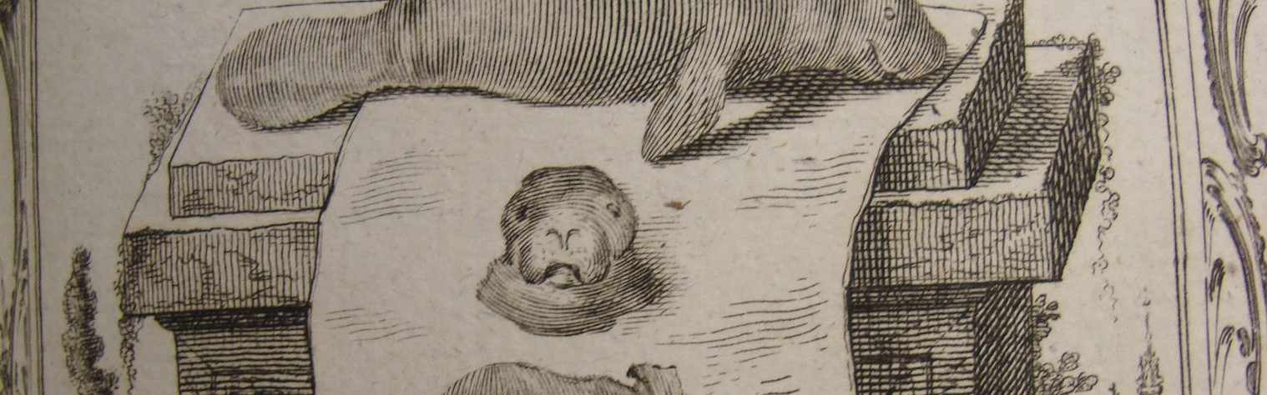

The British Animal Studies Network

CALL FOR PAPERS
‘Loss’
7-9 September 2021 online (hosted by University of Birmingham)
Confirmed plenary speakers are

Ursula K. Heise (UCLA)

Erika L. Milam (Princeton)

The organisers invite lightning talks (of up to 5 minutes) or papers (of 15 minutes) addressing the topic of ‘Loss’ from diverse disciplinary perspectives. Please submit your title, with an abstract of no more than 200 words, a brief biography (also of no more than 200 words), and indicate whether you are proposing a lightning talk or paper. This information should be included in the body of your email – i.e. not as attachments – and directed to Megan Cavell at m.c.cavell@bham.ac.uk. The deadline for abstracts is Monday 28th June 2021. We anticipate circulating pre-recorded lightning talks and papers in advance and hosting discussion sessions, live keynotes and workshops or networking activities in the afternoons of the dates above. If you would like to propose a workshop or networking activity, please do get in touch.
Topics covered at this meeting might include (but are not limited to):
- Species loss and extinction
- Habitat loss, deforestation and loss of natural environments
- Non-human cultures of grief and rituals of lament
- Solastalgia and eco-anxiety
- Temporalities of extinction/the history of extinctions
- Intersectionalities of loss
- Changing relationships with and exploitations of non-human animals
We welcome papers that deal with the theme of ‘Loss’ in both contemporary and historical settings, and especially encourage papers that address these issues from contexts outside the UK. Papers are welcomed from across animal studies, including disciplines such as (but not limited to) geography, anthropology, sociology, literary studies, art history, history, science and technology studies, ethology, psychology, behavioural sciences and ecology, bioscience/biomedical research. We hope to include work by individuals at different career stages.
Further details of the British Animal Studies Network can be found on http://www.britishanimalstudiesnetwork.org.uk

