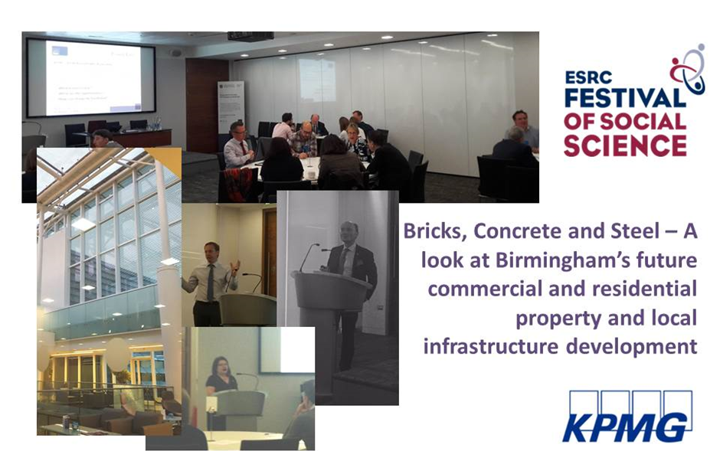

The Dynamic Economic Impact Model (DEIM) is being developed by KPMG and CityREDI as a forecasting tool for the West Midlands Combined Authority (WMCA). As part of the development a set of core elements of research have taken place including:
- An assessment of the housing supply and requirements for the forecast
- An assessment of the skills in the population, and the skills required in the forecast
We see these issues as interlinked, and in economic terms solutions should aim to tackle both. Although scenarios and modelling are still underway, the underpinning work has found that there is a gap in the supply of housing and the supply of skills needed to achieve the forecasts in the strategy. Although the WMCA will be continuing to develop the strategy and projects to achieve the forecasts, at this point in the research it is useful to reflect on these basic findings. The ESRC Festival of Social Sciences encourages universities to engage with the wider research, policy and private sector communities to develop research and ensure it has real impact, affecting change in the world we live in.
With that in mind the event organised by CityREDI and KPMG was aimed at exploring these two issues through a round table discussion with policy-makers, academics, developers and practitioners. After the presentation of findings (slides are available at the City-REDI blog), they were asked to identify barriers and opportunities and how change could be facilitated. Key ideas and messages for the WMCA were:
Barriers
- Perceptions and leadership - currently there are few “West Midlands” allegiances which would facilitate brokering housing or development packages across the region, perceptions need to be changed to see the benefits and opportunities of working collaboratively;
- Making decisions on function of place which ensures long term futures, planning for future purpose, and creating distinct roles for places which are complementary. Understanding whether housing or transport (or what mix) is the solution for place future needs;
- Financing for land and planning -reduced public sector investment and capital availability have reduced the available land and made private sector investment difficult;
- Many development plots are too small for investors, making them unprofitable. For instance, Birmingham has no big (in developer terms) sites within the urban built up area, therefore for them to be worthwhile investments they need to be much bigger packages to attract investors;
- Creating a market for sites which currently have no commercial viability;
- Housing blend and choice is a constraint on meeting the different levels of jobs and demand;
- There are many barriers for different people but affordable housing is a key issue across all groups;
- Social housing stocks continue to reduce which in turn reduces the availability of capital for further investment in social/affordable housing, this is reducing the social purpose objective of housing;
- Different housing models are under used such as the rental sector or part ownership whereas home ownership remains the dominant housing form. This creates inflexibility in the labour market and more pressure on the resident population to supply the skills needed;
- Perceptions of dense housing and willingness to buy/invest/live in dense housing;
- Housing for the elderly which they want to live in, and which offer appropriate and affordable solutions - linked to care and community as the population ages;
- Consistent understanding and evidence across the region which looks at supply and demand or skills and housing (transport and infrastructure) holistically;
- Loss of skills within Local Authorities and reduced investment in staff, making collaboration difficult and putting emphasis on the immediate delivery of planning processes and not long term planning;
- Ability to innovate in times of austerity. When cost cutting, protectionism, simplification (which leads to contracts with large developers, not smaller more innovative propositions), and resources and assets are stripped bare, we need to understand how we can encourage innovation in this climate or find ways to invest in it;
- Optimising existing housing stock - issues were raised with regards to empty or vacant homes, large houses with low occupancy, and unattractive or low demand areas.
Opportunities
- Developers are trying to achieve growth; therefore it is essential for them to be as efficient as possible in delivery of developments to ensure a return on investment. It is usually in their interest to build quickly and where there is demand, therefore given the right conditions they will achieve the housing growth required;
- Having a consistent evidence base which looks nationally and internationally for examples of success and best practice;
- Whole region approach will allow for “packaging” of development to ensure poor investment opportunities are grouped with high value to ensure they are developed, yet creating an offer worth investing in;
- Migration (internal and external) is a solution to the skills problem, but we need to be able to accommodate them and not exacerbate local tensions;
- A collaborative journey of working together brings the opportunity to think across boundaries, think bigger to challenge government for investment and policy change;
- Birmingham and the wider West Midlands could emerge as commuter towns for London; this would put additional strain on the housing but could also be an opportunity for growth, changing the demographics and available working population. This could strengthen a weaker market but it is important to balance this and understand the impact of gentrification and change in local communities and mitigate negative impacts;
- Construction is a major sector in its own right and we manufacture many of the raw products, such as bricks which we supply nationally, so we could see a growth in this sector. This needs to be balanced with the fact that the sector continues to age with high replacement demand needs, even without growth.
Change facilitators
- The Mayor is potentially the greatest change factor, building a sense of place and consistent message that facilitates and drives collaboration from residents, policy makers and developers, enabling all to see the benefits and see how they contribute to the sense of place. The higher geography presents an opportunity to transform places. We need to take lessons from other policy areas such as transport and environment to change behaviours. The Mayor needs to create a vision of what “good” looks like and ensure it is delivered;
- Clear infrastructure planning across the combined authority, which is supported by a consistent and balanced spatial strategy across the region and the role of the land commission in promoting regional/spatial approach to housing and planning. However we must not repeat the mistakes of the past, such as lack of evidence, short term temporal fixes, lack of political willingness to fulfil, working too slow to implement solutions or simply allocating targets that do not take account of local futures;
- Shared skills and resources, where land is already being packaged, teams developing this approach could work across the patch with other planning teams to better integrate the sharing of research, skills and knowledge. This could lead to greater success and tackle issues across local authorities;
- Gateway approach for planners to access packaged developments as a key strand of the spatial strategy and deal with one public sector structure where possible;
- Look at different tax or incentive structures, which could be applied under devolution, to prevent issues such as land banking, vacant or under occupied housing or underinvestment by owners;
- Explore innovative sources of funding for unlocking sites, to pay for remediation, access, infrastructure and utilities.

This research continues and the workshop has highlighted some new research ideas to take forward, but these interim discussions are useful to ensure knowledge and findings are taken account of as early as possible. These interim discussions will be fed into the evolving WMCA structures.

