City-REDI Policy Briefing Series: Improving understanding and measurement of productivity

Cepeda-Zorrilla, M; Green, A; Billing, C; Collinson, S; and Pan, F.

Summary and policy recommendations

- Research shows that employers have only a partial understanding of what productivity means.
- Variations in understanding of productivity across sectors leads to different emphases on what is measured and how. In turn this leads to different actions to improve productivity.
- A lack of recognition and use of the term ‘productivity’ in many cases coupled with the lack of understanding of the notion of value added per employee might lead to disjointed dialogue between policy makers and businesses.
- By focusing solely on productivity as the ratio between output and inputs, key issues – which are particularly important in services - such as quality, speed of delivery and innovation, might remain unaddressed.
- It is essential to review and take account of differences in managers’ understanding and measurement of productivity to find the most appropriate actions that help to improve firm productivity, taking account of sectoral and business size characteristics.

Sectoral differences in understanding productivity by sector in the West Midlands

We can see a clear difference in understanding of productivity across sectors. This is the gap in knowledge that we are seeking to address in our study by exploring the measurement of productivity from the managers’ perspective but not only the way is perceived but also the measures used and the actions taken to improve it.
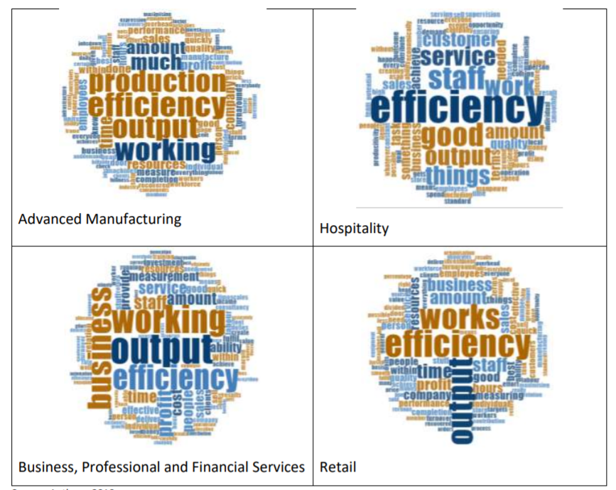

Introduction

Measures of ‘productivity’ are often confused with measures of efficiency. In the four sectors in the West Midlands that our study focused on - Advanced Manufacturing (AM), Retail (R), Hospitality (H) and Business, Professional and Financial Services (BPFS) - ‘efficiency’ is a dominant theme. But other key words such as ‘output’, ‘work’, ‘staff’ and ‘profit’, among others, emerged to varying degrees across the sectors. These sectoral differences in understanding productivity are also linked to differences in prioritising what is measured, and in turn, differences in actions taken to improve the firm performance. Shock events, such as the coronavirus pandemic, have also highlighted the importance of better understanding of what productivity means across different sectors and the relationship with the value added per employee. Understanding better the sectoral differences in what productivity means is essential to target existing policies and policy messages about productivity, so helping them to resonate better with employers in the way that they are intended to (Belt, 2019).

Productivity: definitions and measures

Productivity for the UK

Productivity is considered to have direct impact on individual business success and therefore is a critical determinant of economic growth. The most common definition is that productivity is the ratio between inputs (labour and capital) and the output of goods and services in an economic system. The two main measures of productivity are Total Factor Productivity (TFP) and Labour Productivity (LP).
TFP is concerned with how productively combined inputs (i.e. capital, labour, and other factors) generate gross output. LP is concerned with output per worker. Capital productivity relates to how productively capital is used.

National and sub-national variations in productivity

In the UK productivity is relatively weak in comparison with other European countries. According to the Office for National Statistics (ONS) in 2016 “compared with the rest of the G7, the UK had below average real productivity growth in both output per hour and output per worker terms”. In the West Midlands, labour productivity was 11.9 per cent below the national average (ONS, 2016).
Across the UK although there has been little cumulative growth in productivity in the past few years, there are important regional variations in performance (ONS, 2018).

The West Midlands Local Industrial Strategy equates the regional : national productivity gap as an innovation gap “with around 40 per cent of the output gap between the West Midlands and the UK average due to weaker performance in competition, investment, enterprise and innovation” (HM Government, 2019).
In order to adopt the most appropriate actions to improve productivity, it is essential to have a clear understanding of how is being measured or what we are trying to improve (Tangen, 2005).

Sectoral differences in understanding productivity

A review of the literature shows that understanding what productivity means varies across economic sectors. For instance, in manufacturing productivity “is closely related to the use and availability of resources. Second, productivity is also strongly connected to the creation of value” (Tanglen, 2005). Whereas for the service sector because of its intangibility, openness and process-basedness, this sector productivity should be investigated from the point of view of customers (Linna, et al 2010).

Employer perspectives from the West Midlands

Results from an employer survey

Previous studies exploring productivity from the perspective of ‘industry insiders’ across different economic sectors have found that measures of ‘productivity’ and the term itself is often confused with efficiency (Roper, S. et al, 2019).
Our study which collected data from 300 managers’ firms in the West Midlands region, across the Business Professional and Financial Services (BPFS); Advanced Manufacturing (AM); Retail (R); and Hospitality (H) sectors, found similar results. Our survey found that efficiency and output were the main factors used to explain what productivity means across the four sectors except for H sector which ranked ‘output’ somewhat less importantly (Billing et al, 2020).
Earlier research shows that ‘performance’ can be a more appropriate measure from a business perspective than ‘productivity’ (Sauermann, 2016). But productivity is only one measure of firm performance. Rather than productivity, from an operational perspective firms might concentrate on costs, dependability, flexibility, quality and speed (Slack et al., 2010).
In our study, results show that ‘performance’ was selected to explain what productivity means by many employers in AM, R and BPFS. When asked about indicators of “performance” a large proportion of responses from these three sectors stated ‘customer satisfaction’ and ‘quality of products’ as the main indicators of performance.
‘Work’ / ‘working’ are also important themes across sectors, highlighting the importance of how work is organised for productivity. ‘Production’ emerges as an important theme for AM, but not for the other three sectors, while ‘customer service’ was highlighted in the Hospitality sector (Billing, et al. 2020).
Other themes identified from the manager’s perspective about productivity across the four sectors investigated were:
‘output’ (mentioned by 15% of respondents –examples are: “Outputs per cost input” and “outputting as much as you can at the lowest cost at good standard”;
‘Working’/’work hours’ (mentioned by 13% of respondents – exemplified by “monetary value on working hours per staff member”, “the amount of billable hours we can bill clients for” and “working smart and not harder”); and ‘Staff’/’people’/’workforce’ (identified by 10% of respondents).
These themes were followed by ones related to ‘Production’, Profit/revenue/income/return’; ‘Product/products/stuff/goods’, ‘Sales’ and ‘Time/timescales/speed’.
While ‘Productivity’ is an important performance indicator for businesses across all sectors (with 67% identifying it as ‘very important’ and 95% as ‘very important’ or ‘fairly important’), other indicators such as ‘Customer satisfaction’, ‘Quality of product/service’, ‘Timely service delivery’, ‘Value of sales’ and ‘Profits’ were identified by a larger share of businesses as ‘very important’. ‘Labour efficiency’ had similar rankings to ‘productivity’, while a smaller proportion of businesses ranked ‘Cost of inputs’ as ‘very important’ (Billing et al. 2020).

The productivity debate and the COVID-19 pandemic

A shocking event such as the COVID-19 will have also negative impacts in the medium and long term across all sectors, although some of them will be more affected than others. One study points to “sharp falls (perhaps of a third) in the proportion of innovating firms” (Roper, 2020), which potentially will translate in a wider productivity gap for the Region.
It is also important to note that in some instances businesses which furloughed some of their employees might have seen productivity hold up with fewer workers. In this instances, stable – or indeed increasing – productivity - might be associated with a rise in unemployment. The coronavirus pandemic and associated economic crisis brings this issue of the relationship between productivity and unemployment into sharp relief. However, it is not our key focus of attention here.

Policy Implications

Differences in understanding what productivity means have important implications for policy.
Such differences need to be taken into account in focusing policy actions to improve productivity, both by the government and by employers.
Previous research pointed out that “that many employers focus on the short run” so we can expect many of the employers’ responses here to accord to this timescale. On the other hand “government policy focuses on long-run productivity” (Green et al. 2018).
Government faces the challenge of needing to support businesses with a variety of mechanisms and strategies, differentiated by firm size and economic sector.
The coronavirus pandemic has shown that a shock event can affect businesses in different sectors in different ways, with hospitality (of the four sectors in out study) being disproportionately hard hit (Green, 2020). This adds to the challenges that were already facing government in their attempts to provide business support to raise productivity.
With regard to innovation in the West Midlands, the challenge for the Government is to be able to target loans and funds that can help firms and business to invest in innovating their processes as well as staff and wider workforce training to provide the skills businesses need – now and in the future.

Policy Recommendations

What should policy makers do?
- Review the employer membership of Local Enterprise Partnership and Combined Authority boards to encourage a more diverse group of employers to take local leadership roles and to discuss different approaches to measure and improve productivity (Green et al. 2018)
- Promote and improve the quality of public debate about productivity. Including providing employers with examples of good practice and advice on ways to measure productivity for different sectors studies (Green et al. 2018)
- Develop guidance on how to measure baseline productivity – so that productivity improvements generated by specific actions may be measured and evaluated (Green et al. 2018)
- Continue fostering partnerships between firms and a range of education institutions, to create opportunities for the communities and individuals to help reduce the gap between the availability of the technical skills and those that are required in the region.
- Strengthen the engagement between managers from the different sectors and different firm size characteristics and the local government and institutions providing guidance and business support
- Encourage more Governmental investment in demand-side knowledge sharing to share widely among employers examples of good practice (Green et al. 2018)
- Foster the wide diffusion of new learning on employer strategies, business models and productivity insights arising from challenges and new ways of working in the coronavirus crisis.

Further reading
- Billing, C., Zorrilla, M.C., Collinson, S., Green, A. and Pan, F. 2020. Regional Productivity Differences, Skills and Inclusive Growth: Survey Findings.
- Green, A. 2020. The Impact of the COVID-19 Crisis on Older Workers. CityREDI Blog.
- Green, A; Sissons, P; Qamar, A and Broughton, K. 2018 Raising productivity in low-wage sectors and reducing poverty. JRF Report.
- HM Government . 2019. West Midlands Local Industrial Strategy.
- Linna, P., Pekkola, S., Ukko, J. and Melkas, H., 2010. Defining and measuring productivity in the public sector: managerial perceptions. International Journal of Public Sector Management.
- Office for National Statistics (ONS). 2016. International comparisons of UK productivity (ICP), final estimates: 2016.
- Office for National Statistics (ONS). 2018. Regional labour productivity, including industry by region, UK: 2018.
- Roper S. 2020. Enterprise Research Centre, Warwick Business School. R&D and innovation after Covid-19: What can we expect? A review of trends after the financial crisis.
- Roper, S., Hathaway, K. and Driffield, N. (2019) Understanding value added per employee in six UK sectors: The insiders’ view, Enterprise Research Centre and Centre for Progressive Policy.
- Sauermann, J., 2016. Performance measures and worker productivity. IZA World of Labor.
- Slack, N, Chambers, S and Johnston, R (2010) Operations management. Harlow: Financial Times Prentice Hall
- Tangen, S. (2005), "Demystifying productivity and performance", International Journal of Productivity and Performance Management, Vol. 54 No. 1, pp. 34-46.

