12. Character and structure in A Christmas Carol

The opening of a text is crucial for the creation of the fictional world. In this activity, we look at how a text can draw on conventional patterns to begin a story and how an opening chapter can use repetition to bring crucial elements of the fictional world into focus.

Activity 12.1 The opening of fairy tales
- Read the first two pages of A Christmas Carol up until the extract below. How does the phrase once upon a time function in the context of the first two pages?
- Begin by comparing the occurrence of once upon a time in A Christmas Carol to how it is used in ChiLit, 19C and DNov. You would do this by selecting these corpora in CLiC, and then search for the term once upon a time as a “Whole phrase”.

Once upon a time--of all the good days in the year, on Christmas Eve--old Scrooge sat busy in his counting-house. It was cold, bleak, biting weather: foggy withal: and he could hear the people in the court outside, go wheezing up and down, beating their hands upon their breasts, and stamping their feet upon the pavement stones to warm them. The city clocks had only just gone three, but it was quite dark already-- it had not been light all day--and candles were flaring in the windows of the neighbouring offices, like ruddy smears upon the palpable brown air. The fog came pouring in at every chink and keyhole, and was so dense without, that although the court was of the narrowest, the houses opposite were mere phantoms. To see the dingy cloud come drooping down, obscuring everything, one might have thought that Nature lived hard by, and was brewing on a large scale.
(A Christmas Carol, Charles Dickens, Chapter 1)

Below is a screen shot of the concordance search for once upon a time in ChiLit. Examples such as lines 10, 11, and 13 show how once upon a time is found at the very beginning of the book. This is also indicated by the last column, where the slider indicates the position in the text. Although line 17 looks as if there is text before the sentence with once upon a time, this text is a Wordsworth quotation, before the story of the Water-babies begins with “Once upon a time there was a little chimney-sweep, and his name was Tom.”

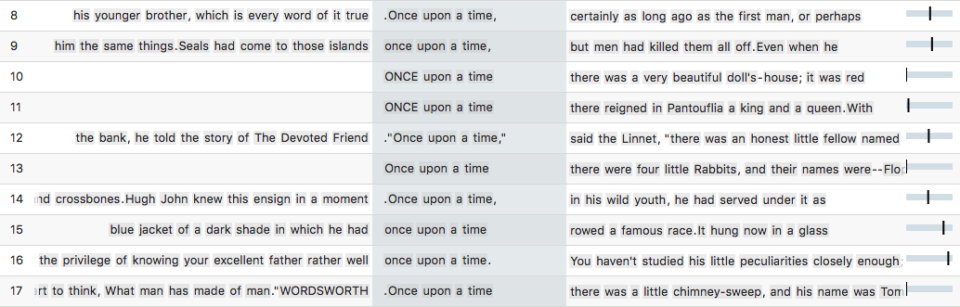
Figure 1: Sample of instances of once upon a time in the 19th Century Childrens Literature Corpus ChiLit

While today we recognize once upon a time as a typical beginning for a children’s story or a fairy tale, in the 19th century, the phrase could also be used as a more general time adverbial as in the example below:

"No, no; it's not so bad as that, my boy. I've better eyes than most people, and then I had the privilege of knowing your excellent father rather well once upon a time. You haven't studied his little peculiarities closely enough; but you'll improve. By the way, where _is_ your excellent father all this time?"
(Vice Versa, F. Anstey, Chapter 18)

Concordances for once upon a time in 19C and in DNov show that the phrase is used in neither of the two corpora to begin a text. It is used either as a general time adverbial as in the above example, or when a story is told at some point in the narrative. In A Christmas Carol, once upon a time appears two pages into the narrative. The first person narrator starts by talking about the fact that Marley is dead and by describing Scrooge as a miserly and unfeeling person. Both these points are extensively made. The fact that Marley is dead is restated, emphasized – “You will therefore permit me to repeat, emphatically, that Marley was dead as a door-nail” – and backed up with evidence – “The register of his burial was signed by the clergyman, the clerk, the undertaker, and the chief mourner”. Because Scrooge was Marley’s only friend, he is very clear about the fact Marley is dead – note the list of “sole executor, etc”. The narrator puts equal emphasis on the fact that Scrooge has a miserable and monotonous existence: see the list of squeezing, wrenching, grasping, etc. And he can’t be moved by anything: “External heat and cold had little influence on Scrooge.” Both points (Marley dead and Scrooge cold and unmoved by anything) are crucial preparation for the story that starts with once upon a time.
At the beginning of the story, important points are made that are linked back to in later parts of the text. Look at the extract below. In this passage, Scrooge sees the door-knocker as Marley’s face. The word knocker is repeated five times to help make the point. Also note how the door-nail from the beginning of the text (“Old Marley was as dead as a door-nail”), relates to “the screws and nuts that held the knocker on” in the last sentence of this extract.

Now, it is a fact, that there was nothing at all particular about the knocker on the door, except that it was very large. It is also a fact, that Scrooge had seen it, night and morning, during his whole residence in that place; also that Scrooge had as little of what is called fancy about him as any man in the city of London, even including--which is a bold word--the corporation, aldermen, and livery. Let it also be borne in mind that Scrooge had not bestowed one thought on Marley, since his last mention of his seven years' dead partner that afternoon. And then let any man explain to me, if he can, how it happened that Scrooge, having his key in the lock of the door, saw in the knocker, without its undergoing any intermediate process of change--not a knocker, but Marley's face.

Marley's face. It was not in impenetrable shadow as the other objects in the yard were, but had a dismal light about it, like a bad lobster in a dark cellar. It was not angry or ferocious, but looked at Scrooge as Marley used to look: with ghostly spectacles turned up on its ghostly forehead. The hair was curiously stirred, as if by breath or hot air; and, though the eyes were wide open, they were perfectly motionless. That, and its livid colour, made it horrible; but its horror seemed to be in spite of the face and beyond its control, rather than a part of its own expression.

As Scrooge looked fixedly at this phenomenon, it was a knocker again.

To say that he was not startled, or that his blood was not conscious of a terrible sensation to which it had been a stranger from infancy, would be untrue. But he put his hand upon the key he had relinquished, turned it sturdily, walked in, and lighted his candle.

He did pause, with a moment's irresolution, before he shut the door; and he did look cautiously behind it first, as if he half expected to be terrified with the sight of Marley's pigtail sticking out into the hall. But there was nothing on the back of the door, except the screws and nuts that held the knocker on, so he said "Pooh, pooh!" and closed it with a bang.
(A Christmas Carol, Charles Dickens, Chapter 1)

In A Christmas Carol, the word knocker appears 7 times overall. We have seen the first five occurrence in the extract above. The concordance in Figure 2 shows that there are two more occurrences which are both at the end of the book, in the final chapter.

The hand in which he wrote the address was not a steady one, but write it he did, somehow, and went down-stairs to open the street door, ready for the coming of the poulterer's man. As he stood there, waiting his arrival, the knocker caught his eye.

"I shall love it, as long as I live!" cried Scrooge, patting it with his hand. "I scarcely ever looked at it before. What an honest expression it has in its face! It's a wonderful knocker!--Here's the Turkey! Hallo! Whoop! How are you! Merry Christmas!"

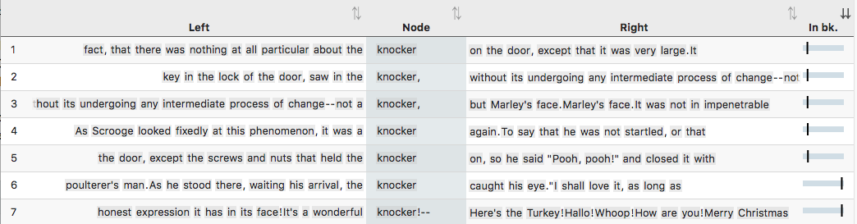
Figure 2: All 7 instances of knocker in A Christmas Carol

While the door-knocker supports the framing of the story, the word fire also appears at the beginning but runs more through the story.

Activity 12.2 Fire in A Christmas Carol
- Read the extract below and describe what fire means for Scrooge.

The door of Scrooge's counting-house was open that he might keep his eye upon his clerk, who in a dismal little cell beyond, a sort of tank, was copying letters. Scrooge had a very small fire, but the clerk's fire was so very much smaller that it looked like one coal. But he couldn't replenish it, for Scrooge kept the coal-box in his own room; and so surely as the clerk came in with the shovel, the master predicted that it would be necessary for them to part. Wherefore the clerk put on his white comforter, and tried to warm himself at the candle; in which effort, not being a man of a strong imagination, he failed.
(A Christmas Carol, Charles Dickens, Chapter 1)

- Go to http://clic.bham.ac.uk/concordance
- Run a concordance for fire in A Christmas Carol (you will find the text in the set of corpora titled ArTs – Additional Requested Texts, but you can also start typing the book title and CLiC will just autocomplete the search box).
- Notice (by looking at the distribution of locations under the “In bk.” column) that fire is evenly distributed across the text.
- Look at the different types of fire: large or small, strong or feeble, social or solitary, and note whose house each one is in.

This activity is just one example from the activities in our free activity book that you can download from our website:

Mahlberg , M., Stockwell, P., & Wiegand, V. (2017). CLiC – Corpus Linguistics in Context: An Activity Book Version 1. University of Birmingham. https://birmingham.ac.uk/clic-activity-book

We welcome your feedback on our activities – please get in touch with comments, suggestions!

