11. Exploring theme in The Sign of the Four
In this activity we will make use of the concordance and annotation tools to explore two themes in Arthur Conan Doyle’s 1890 novel featuring Sherlock Holmes, The Sign of the Four. We will look at justice and the role of women.

Activity 11.1 Justice
- Go to the CLiC Concordance tab (http://clic.bham.ac.uk/concordance).
- Select The Sign of the Four in the “Search the Corpora” box. You can start typing the book title and CLiC will autocomplete or you can scroll down to find it in the section entitled “ArTs – Additional Requested Texts”.
- Select the subset “Quotes”.
- Under “Search for terms”, type the word justice.

Who speaks about justice in the novel? Go through the concordance lines and check the speaker. (Remember – you can click on the graphic in the column “In bk.” to the right hand side in order to go to the concordance line in the full context of the book itself).
We can tag each line to keep track of who the speaker is in each case, as follows. In this example, there are not many speakers, but you can see how this technique would be very useful with a very large number of concordance lines or many more speakers.

Activity 11.2 Who speaks about justice?
- Carry on from step 4 of Activity 11.1 above.
- Click on “Manage tag columns” on the right side-panel and add a tag for each speaker that you can find. To do this, click on “Add new”, and a tag will appear in the box above labelled “new-tag”. Click on this label to highlight it, and then in the box below (headed “Rename selected tag column”) type, for example, holmes. Click anywhere in the blank space in the top box and the “new-tag” will change its name.
- Repeat for each speaker you can find, as shown in this screenshot.

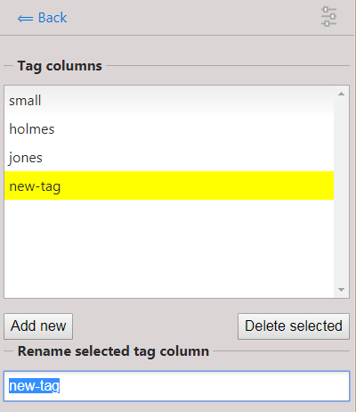
Figure 1: Creating and renaming new tags for annotation

Figure 2: The procedure for annotating instances of justice for the character name

- When you have finished, click “⟸ Back” at the top of the grey panel to take you back to the Concordance column. You will see your tags listed at the bottom, and also listed to the right of “in bk.” for each concordance line.
- To tag each line with the right speaker, select the concordance line (by clicking on it) and press the tick in the tag menu as shown in the following screenshot. You will see a tick appear to the right of each line, under the selected speaker.

You will be able to see at a glance which character mentions the word justice the most. In this case, it is Sherlock Holmes, and then Jonathan Small. Again, this small simple example can be scaled up to search for similar terms across larger texts or corpora, and with many more characters.
It is worth drilling down into the chapter contexts to see whose justice Holmes and Small are talking about. You could repeat the activity so far with different terms from justice to explore other themes that preoccupy characters in the novel.

A simple way of exploring themes relating to gender representation in the novel can be undertaken as follows.

Activity 11.3 The role of women in Sherlock Holmes
- Start again. Go to the CLiC Concordance tab (http://clic.bham.ac.uk/concordance).
- Select The Sign of the Four in the “Search the Corpora” box, as before.
- Under “Search for terms”, type the words woman and women. Select the option “Any word” to search for both at once.
- Read through the concordance lines: how are women described?

You might notice that the concordance shows that the words woman and women often occur with adjectives in the ‘L1’ position (directly to the left of the search word) in The Sign of the Four. These adjectives relate to appearance (for example, attractive, be-diamonded, graceful, red-faced, slatternly, small). And of course the adjective wronged links back to the theme of justice. Some of these patterns suggest that women are weak objects of attraction (see the appearance words) and need help (“the shrill, broken whimpering of a frightened woman”).
Other possible themes for exploration include, for example, imperialism and the Victorian fear of foreign influences. It is always worth checking what themes other readers have noticed, either by consulting works of published literary criticism for scholarly material, or by searching for reading groups and social media responses more informally. Intuitions of such readers can be explored systematically using the CLiC tool.

Activity 11.4 Finding and exploring further themes
- Watch the BBC Bitesize video “Themes in The Sign of Four” at https://www.bbc.co.uk/education/guides/zx7mxnb/revision
- Choose another theme mentioned in the video and look for related words or phrases in the CLiC concordance tab, following the proecdures set out in the Activities above.

Further reading
- “BBC Bitesize learner guides and class clips for The Sign of the Four”: https://www.bbc.co.uk/education/topics/zx8pycw
- “The Sign of the Four – Big Ideas” – Teaching resources shared by Millie Frost (@MissMFrost on Twitter), shared with the #TeamEnglish Twitter community: https://www.dropbox.com/sh/s16vspfqod4ez6q/AADGsZoG0c1c2FxM8TGiT8I-a?dl=0

This activity is just one example from the activities in our free activity book that you can download from our website:

Mahlberg , M., Stockwell, P., & Wiegand, V. (2017). CLiC – Corpus Linguistics in Context: An Activity Book Version 1. University of Birmingham. https://birmingham.ac.uk/clic-activity-book

We welcome your feedback on our activities – please get in touch with comments, suggestions!

