15. Education, women and governesses in the 19th century

Following on from the very simple search for gender terms in Activity 11 above, we can explore further and more specific aspects of gender roles in 19th century fiction using CLiC. Young, educated women could find respectable work in upper middle class and landowning households as governesses for the family’s children. These positions occupied an uneasy location between being a servant and being part of the household, and as a consequence governesses were often isolated or in an ambivalent social position. These factors, of course, make the role an ideal one for literary fictional narrative.

Activity 15.1 The governess

- Watch the British Library video “The Governess” on Youtube (or search for “British Library” and “governess”.
- Summarise how the video describes the life of a governess in 19th century British society and literature. Can you think of any novels with a governess among the characters?

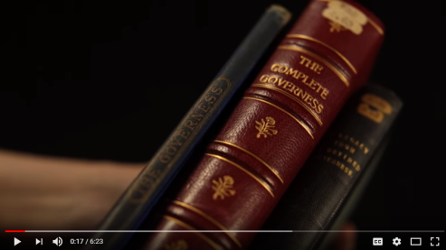
British Library – “The Governess”

https://www.youtube.com/watch?v=tlOkWIxqqWs

Examples of famous literary governesses include Rebecca Sharp in Thackeray’s Vanity Fair, Jane Eyre in the novel by Charlotte Brontë, Agnes Grey in Anne Brontë’s novel, Madame de la Rougierre in Le Fanu’s Uncle Silas, the unnamed governess in Henry James The Turn of the Screw, Miss Wade in Dickens’s Little Dorrit, Jane Fairfax in Jane Austen’s Emma, and many others. Given her interest in the grand country house and estate as the setting for several novels, Jane Austen’s writing features several instances of a governess as a significant character.

Activity 15.2 Austen’s governesses

- Go to the CLiC Concordance tab (http://clic.bham.ac.uk/concordance).
- Select novels by Jane Austen in the “Search the Corpora” box. You can start typing “Austen” and CLiC will show all of Austen’s novels which you then need to select one by one.
- Select the subset “All text”.
- Under “Search for terms”, type the word governess.

You should get a concordance that looks like this:

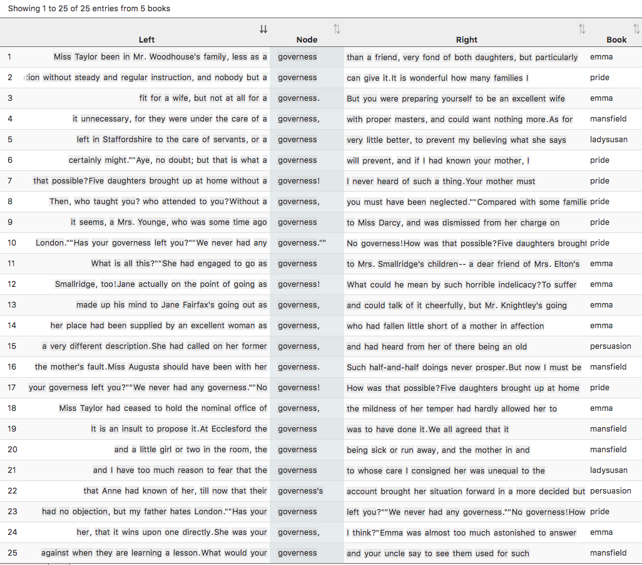
Figure 1: All 25 instances of governess in Jane Austen’s novels

This shows all instances of governess in Jane Austen’s novels. Look closely at the concordance lines to get a swift overview of how governesses are described and their position in society. Again, clicking on the “In bk.” column to the right of a line will give you the full context of the line in its original passage.

Activity 15.3 The social status of governesses in Pride and Prejudice
- Following on from step 6 above, find the line that includes the sentence “Has your governess left you?” You will see to the right of the concordance line that this is from “pride” (Pride and Prejudice), chapter 29, paragraph 26, and it is sentence 71. Click on the “in bk.” graphic to the right, and CLiC will open the passage concerned from the novel.
- The short passage contains a wealth of evidence for the status of governesses and the attitudes of families towards them. What does it telll you about families who employed a governess and those that didn’t?

Here is the passage.

"Has your governess left you?"
"We never had any governess."
"No governess! How was that possible? Five daughters brought up at home without a governess! I never heard of such a thing. Your mother must have been quite a slave to your education."
Elizabeth could hardly help smiling as she assured her that had not been the case.
"Then, who taught you? who attended to you? Without a governess, you must have been neglected."
"Compared with some families, I believe we were; but such of us as wished to learn never wanted the means. We were always encouraged to read, and had all the masters that were necessary. Those who chose to be idle, certainly might."
"Aye, no doubt; but that is what a governess will prevent, and if I had known your mother, I should have advised her most strenuously to engage one.I always say that nothing is to be done in education without steady and regular instruction, and nobody but a governess can give it. It is wonderful how many families I have been the means of supplying in that way. I am always glad to get a young person well placed out. …"
(Jane Austen, Pride and Prejudice, Chapter 29)

Note that it is also important to frame these comments by noticing whose views are being expressed. In this passage, the character Lady Catherine is allowed almost to speak for herself: her speech is even largely free of the narrator adding reporting clauses like she said. Elsewhere in the novel, the narrator gives opinions about governesses directly, and sometimes a character’s perspective is blended with or filtered through the narratorial content (as ‘Free Indirect Discourse’). This happens in the narrated paragraph just above the passage excerpted here from Chapter 29. Go and read through it in the CLiC context page (you can find it from the CLiC table of contents at clic.bham.ac.uk under Pride and Prejudice). You can see Austen using her narrator to provide characterisation of Lady Catherine in the manner in which she is presented, before she speaks.

CLiC includes a section of corpora of “ChiLit – 19th Century Children’s Literature”, which you can find in the “Search the corpora” box. Scroll down to find individual novels, such as Frances Hodgson Burnett’s The Secret Garden.

Activity 15.4 Children’s feelings about governesses

- Start again by going to the CLiC Concordance tab (http://clic.bham.ac.uk/concordance).
- Find “The Secret Garden” in the “Search the corpora” box, and select it.
- Search in “All text” for the term governess.
- You should find 8 examples.
- Explore their contexts by clicking on the graphic “In bk.” for each line.

The line containing the speech, “‘I don’t want a governess’, said Mary sharply”, occurs in the following passage.

"Why, our Dickon's eyes nearly started out o' his head, they got that round," answered Martha. "But mother, she was put out about your seemin' to be all by yourself like. She said, 'Hasn't Mr. Craven got no governess for her, nor no nurse?' and I said, 'No, he hasn't, though Mrs. Medlock says he will when he thinks of it, but she says he mayn't think of it for two or three years.'"
"I don't want a governess," said Mary sharply.
"But mother says you ought to be learnin' your book by this time an' you ought to have a woman to look after you, an' she says: 'Now, Martha, you just think how you'd feel yourself, in a big place like that, wanderin' about all alone, an' no mother. You do your best to cheer her up,' she says, an' I said I would."
(Frances Hodgson Burnett, The Secret Garden, Chapter 8)

What advantages do the adults see in getting a governess for Mary? And what does Mary think about it?

Activity 15.5 Broadening the exploration

- Choose one of the following corpora in CLiC from the Concordance tab (http://clic.bham.ac.uk/concordance):
  - Dickens’s Novels (DNov)
  - The 19th Century Reference Corpus (19C)
  - The 19th Century Children’s Literature Corpus (ChiLit)

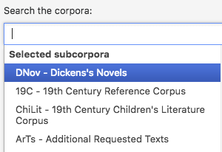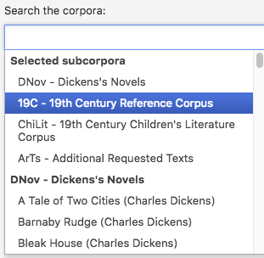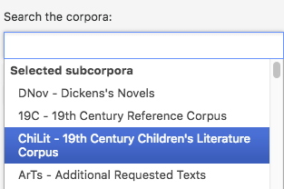
Figure 2: Choosing corpora

- Run a concordance for governess in the chosen corpus.
- Go through the concordance and try to find examples for at least one of the following questions:
  - What examples can you find for the points mentioned in the British Library video, in Activity 15.1 above, about the tension that a governess would have felt in the 19th century, being neither part of the family nor of the servants?
  - Which children do the governesses look after? What does this tell you about childhood in the 19th century?
  - What is the social background of the governesses? Why do they choose the job?

Further reading
“Orphans in fiction” – British Library
https://www.bl.uk/romantics-and-victorians/articles/orphans-in-fiction

This activity is just one example from the activities in our free activity book that you can download from our website:

Mahlberg , M., Stockwell, P., & Wiegand, V. (2017). CLiC – Corpus Linguistics in Context: An Activity Book Version 1. University of Birmingham. https://birmingham.ac.uk/clic-activity-book

We welcome your feedback on our activities – please get in touch with comments, suggestions!

