Teaching the 19th-century novel
Exercise 1.a: The beginning of A Christmas Carol

For Dickens, as for most authors, the beginning of the story is very important. The way in which a story begins can be important for the development of the story or of a character.
In A Christmas Carol, the reform that Scrooge undergoes, his “redemption” is a key theme.
Look at this extract from the beginning of A Christmas Carol. Highlight / underline words that are important for creating the atmosphere and that foreshadow the appearance of the ghosts.
- Can you find any examples of contrast?
- How is the weather described?

Once upon a time--of all the good days in the year,
on Christmas Eve--old Scrooge sat busy in his
counting-house. It was cold, bleak, biting weather: foggy
withal: and he could hear the people in the court outside,
go wheezing up and down, beating their hands
upon their breasts, and stamping their feet upon the
pavement stones to warm them. The city clocks had
only just gone three, but it was quite dark already--
it had not been light all day--and candles were flaring
in the windows of the neighbouring offices, like
ruddy smears upon the palpable brown air. The fog
came pouring in at every chink and keyhole, and was
so dense without, that although the court was of the
narrowest, the houses opposite were mere phantoms.
To see the dingy cloud come drooping down, obscuring
everything, one might have thought that Nature
lived hard by, and was brewing on a large scale.
(A Christmas Carol, Stave 1, paragraph 10)
Notes

Exercise 1.b: The use of “fog*” across A Christmas Carol

Open the CLiC website in the Chrome browser (clic.bham.ac.uk)
- Click on the “Concordance tab”
- Under “Search the corpora”, select “A Christmas Carol: A Ghost Story of Christmas (Charles Dickens)” – a fast option to select it is to start typing “Carol” and the title will be recommended.
- Under “Search for terms”, enter “fog*” (the * is a “wildcard”, a placeholder for extra letters, so you will find words like foggy).
- For each concordance line, click on the slider to see the “in bk.” (“in book”) view. Check the context for each occurrence: how is “fog” used here?
- Describe the development that the different occurrences indicate from the beginning to the end of the novella.
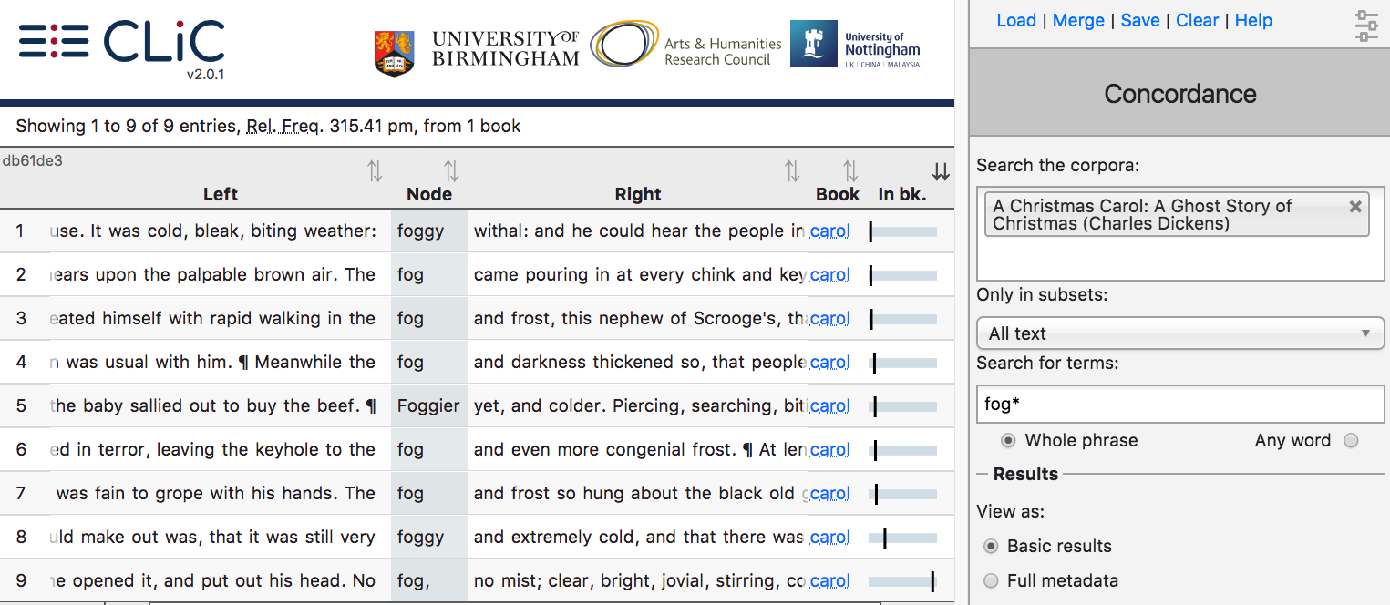
1.
2.
3.
4.

A concordance displays all occurrences of a word, phrase, or pattern in a text
or set of texts.

Notes

Exercise 1.c: The use of “fog*” across Dickens’s novels & A Christmas Carol

- Stay in the “Concordance tab”
- Under “Search the corpora”, keep “A Christmas Carol” and add “DNov – Dickens’s Novels”
- Under “Search for terms”, keep “fog*”
- Under “Results” – “View as” choose the “Distribution plot”. You should then see a plot like this (but with all 15 entries).
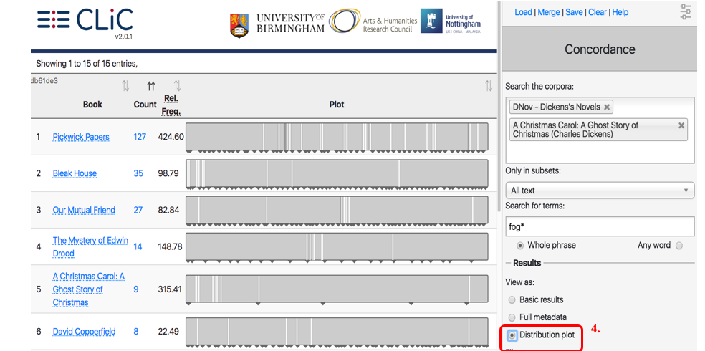
A distribution plot displays an overview of the occurrences of a word, phrase or pattern across a text or set of texts.

- How is “fog*” distributed across the texts?
- In which texts does “fog*” occur a lot at the beginning?
- Click on a line on the distribution plot to see the context of a particular occurrence.
Notes

Exercise 1.d: Structure and beginning

Read the following extracts from the beginnings of Bleak House and Great Expectations. Can you find any similarities to the beginning of A Christmas Carol?

Fog everywhere. Fog up the river, where it flows among green aits and meadows; fog down the river, where it rolls deified among the tiers of shipping and the waterside pollutions of a great (and dirty) city. Fog on the Essex marshes, fog on the Kentish heights. Fog creeping into the cabooses of collier-brigs; fog lying out on the yards and hovering in the rigging of great ships; fog drooping on the gunwales of barges and small boats. Fog in the eyes and throats of ancient Greenwich pensioners, wheezing by the firesides of their wards; fog in the stem and bowl of the afternoon pipe of the wrathful skipper, down in his close cabin; fog cruelly pinching the toes and fingers of his shivering little 'prentice boy on deck. Chance people on the bridges peeping over the parapets into a nether sky of fog, with fog all round them, as if they were up in a balloon and hanging in the misty clouds.
(Bleak House, Chapter 1, paragraph 2)

Ours was the marsh country, down by the river, within, as the river wound, twenty miles of the sea. My first most vivid and broad impression of the identity of things, seems to me to have been gained on a memorable raw afternoon towards evening. At such a time I found out for certain, that this bleak place overgrown with nettles was the churchyard; and that Philip Pirrip, late of this parish, and also Georgiana wife of the above, were dead and buried; and that Alexander, Bartholomew, Abraham, Tobias, and Roger, infant children of the aforesaid, were also dead and buried; and that the dark flat wilderness beyond the churchyard, intersected with dykes and mounds and gates, with scattered cattle feeding on it, was the marshes; and that the low leaden line beyond, was the river; and that the distant savage lair from which the wind was rushing, was the sea; and that the small bundle of shivers growing afraid of it all and beginning to cry, was Pip.
(Great Expectations, Chapter 1, paragraph 3)
Notes

Exercise 2: Strategies for exploring themes with CLiC (poverty)

To study themes with CLiC, we have to think of strategies to find the relevant sections in a text. Some themes are signalled by the exact word (for example, a search for “family” is a good start to explore the theme of family), but this does not work for all themes.

- What search words would you use to explore the theme of poverty in A Christmas Carol?
- Click on the concordance tab. Select only “A Christmas Carol”.
- Try searching for “workhouse*”. How many occurrences do you find?
- What is the relationship between the occurrences and how does this link to the main themes of the novel?
Notes

Exercise 3: The significance of doors in J&H

- Go to the concordance tab.
- Under “Search the corpora”, select “The Strange Case of Dr Jekyll and Mr Hyde”
- Leave “Only in subsets” at “All text”
- Under “Search for terms”, type “door*”
- Look through the concordance lines.
- Use the KWICGrouper to explore the description of doors.
- Categorise the lines with help of the “tag” menu:
  - what can you find out about the function of doors in the novella?
  - are there any patterns in the descriptions of doors, or actions that accompany them?
  - do the functions stay consistent or do they vary across the chapters?
Notes

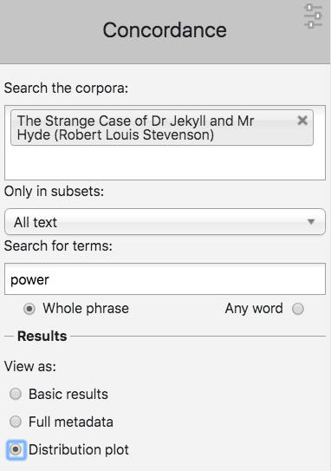
Exercise 4: Power in J&H

- Which words in Jekyll & Hyde refer to the theme of power? Draw on your memory or explore the wordlist (Go to “Clusters”, under “Only in subsets:” select “All text” and leave “n-gram” at “1-gram”.
- Fill Table 2 with the words you have identified. Use the concordance tab to find out how these words are used in context. See if you can identify any wider patterns of their use.
- Use the “distribution plot” view in the concordance tab to trace the uses of words across the text. Write down in which chapters the words are used.

Table 2. Gathering evidence for the theme of power in Jekyll & Hyde
Theme:  Power | Words associated with theme (e.g. synonyms of the word) that appear in the novel:
Patterns within the theme (w/context): | Both | Patterns within the theme (w/context):
[Evidence/chapter no.] | [Evidence/chapter no.] | [Evidence/chapter no.]
Other observations:

Applications

How would you use CLiC in your teaching?

- Which group of students?
- In the classroom / independent homework / teacher-only (e.g. lesson planning)?
- Which texts (that are available in CLiC)? Note that CLiC also contains some nonfiction!
- In combination with other materials / tools?
- How could CLiC be incorporated into an NEA? Which texts could the CLiC texts be compared to?

Further reading

Resources & articles
- Our CLiC Activity Book: www.birmingham.ac.uk/clic-activity-book
- Mahlberg, M., Wiegand, V., Hobday, S., & Child, F. (2019). Digital methods for the English classroom. Impact: Journal of the Chartered College of Teaching, 7. Available from https://impact.chartered.college/article/digital-methods-for-the-english-classroom/
- Mahlberg, M., & Stockwell, P. (2016). Point and CLiC: Teaching literature with corpus stylistic tools. In M. Burke, O. Fialho, & S. Zyngier (Eds.), Scientific Approaches to Literature in Learning Environments (pp. 251–267). Amsterdam: John Benjamins. Available from https://www.academia.edu/31169469/Point_and_CLiC_Teaching_
literature_with_corpus_stylistic_tools
- Mahlberg, M. (2015). Corpus Linguistics. In M. Giovanelli, A. Macrae, F. Titjen and I. Cushing (eds.) English Language and Literature: A/AS Level for AQA Student Book (pp. 284-286). Cambridge: Cambridge University Press.
- Mahlberg, M., Wiegand, V., Stockwell, P., & Hennessey, A. (2019). Speech-bundles in the 19th-century novel. Language and Literature, 28(4), 326-253. Available from https://doi.org/10.1177/0963947019886754

Blog posts
- Adriano, L. (2018, March 5). CLiC in the Classroom [Blog post]. Retrieved from https://blog.bham.ac.uk/clic-dickens/2018/03/05/clic-in-the-classroom/
- Howard, K. (2018, March 27). What’s in a Word: Revision with CLiC [Blog post]. Retrieved from https://blog.bham.ac.uk/clic-dickens/2018/03/27/whats-in-a-word-revision-with-clic
- Kemp, B. (2018, April 5). Revising Frankenstein with CLiC Dickens [Blog post]. Retrieved from https://blog.bham.ac.uk/clic-dickens/2018/03/27/whats-in-a-word-revision-with-clic
- Mahlberg, M. & Wiegand, V. (2019) Finding links between the structure and themes of A Christmas Carol [Blog post]. Retrieved from https://blog.bham.ac.uk/clic-dickens/2019/05/17/finding-links-between-the-structure-and-themes-of-a-christmas-carol/
- Stoneman, C. (2018, June 8). Signposting and gatekeeping the supernatural: Servants and doors in The Strange Case of Dr Jekyll and Mr Hyde [Blog post]. Available from https://blog.bham.ac.uk/clic-dickens/2018/06/08/signposting-and-gatekeeping-the-supernatural/

Using CLiC

Take a screenshot: Use the Windows ‘snipping tool’ and select the area that you want to include. Save the screenshot with a meaningful name. When you include concordance lines in your document, make sure to write down if they were a sample or all of the lines. For example: “15 out of 28 examples of vampire in Dracula”.

Tagging results: Create your own tags with the ‘Manage tag columns’ menu. In that menu, just click on ‘add new’, then select the new tag and rename it (to something meaningful). When your results are tagged you can sort the concordance by the tags.
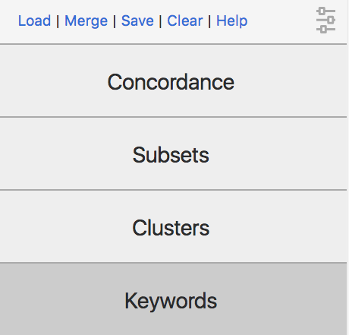
Saving results: Use the ‘Save’ button in the top right. You can then open the spreadsheet (for example of a concordance or a keyword list) in a spreadsheet viewer like Excel. If you have tagged a concordance, you can download the tagged results.

Copy the link: just copying and pasting a link to a concordance allows you to get back to the same results!

Loading results: When you come back to your research tomorrow, you can click on the ‘load’ button (in the same menu) to reload your query – together with your tags!

Merging results – combining your tags with other people’s tags: If you and somebody else both save a tagged concordance and want to compare if you tagged the same lines, you can use the ‘Merge’ button. This allows you to upload and combine two sets of tags.

Sorting by several columns – You already know how to sort a concordance by the first word on the right or on the left – and even by the word or phrase in the middle (the ‘node’). You can also sort the lines by the order in which they appear in the book by clicking on the ‘in bk.’ column. But what if you want to order them by the order in the book and by the right-hand side? Simply press the ‘shift’ button while you click on the two column headers! The one that you click first will be sorted first.

Advanced information is available from the CLiC User Guide. Just click on the ‘Help’ button in the top right corner of the CLiC page. This will take you to the CLiC Help menu where you can view and/or download the User Guide.

